HYDROPOWER
Hydropower or hydroelectricity refers to the conversion of energy from flowing water into electricity. It is considered a renewable energy source because the water cycle is constantly renewed by the sun.
Historically, one of the first uses of hydro power was for mechanical milling, such as grinding grains. Today, modern hydro plants produce electricity using turbines and generators, where mechanical energy is created when moving water spins rotors on a turbine. This turbine is connected to an electromagnetic generator, which produce electricity when the turbine spins.
Hydropower is the largest contributor of all renewable energy sources and accounts for 6.7% of worldwide electricity production. Hydropower is an abundant, low cost source of power (where applicable), despite high upfront buidling costs. It is also a flexible and reliable source of electricity compared to other renewable options, as it may be stored for use at a later time. Dammed reservoirs can also help with flood control, be a reliable water supply, and may be used for recreational purposes.
However, there are many concerns with hydropower, particularly large dam facilities. Damming a river has a significant impact on the regional ecosystem, by flooding upstream landscapes, distrupting habitats for wildlife, blocking fish passages, and often displacing local communities. In addition, dam failures can be catastrophic, further disrupting landscapes and claiming the lives of those living downstream.
Finally, hydroplants are not completely free of greenhouse gas emissions. As with most forms of energy, carbon dioxide emissions occur during construction, particularly as a result of the large quantities of cement used, and loss of vegetation in flooded areas creates methane, another greenhouse gas, as it matter decays underwater.

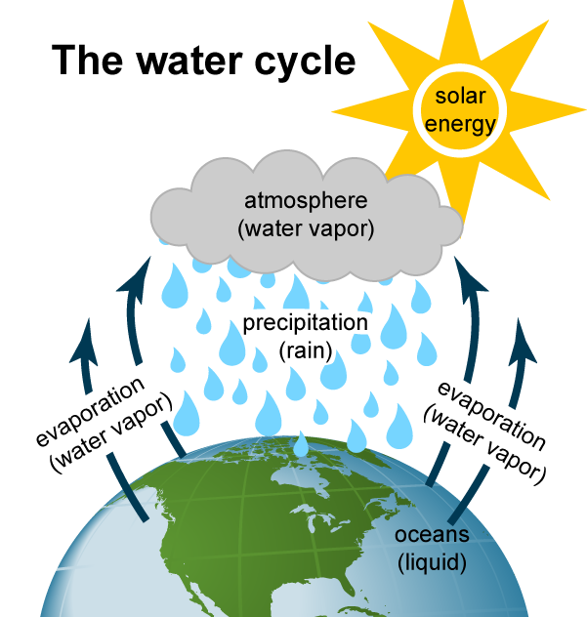

SOLAR POWER
Solar power is usable energy generated from the sun in the form of electric or thermal energy. Solar energy is captured in a variety of ways, the most common of which is with photovoltaic solar panels that convert the sun’s rays into usable electricity. Aside from using photovoltaics to generate electricity, solar energy is commonly used in thermal applications to heat indoor spaces or fluids. Residential and commercial property owners can install solar hot water systems and design their buildings with passive solar heating in mind to fully take advantage of the sun's energy with solar technology.
Solar energy is a clean, inexpensive, renewable power source that is harnessable nearly everywhere in the world - any point where sunlight hits the surface of the earth is a potential location to generate solar power. And since solar energy comes from the sun, it represents a limitless source of power. Renewable energy technologies generate electricity from resources that are infinite. Compare, for instance, producing electricity with renewable resources to doing so with fossil fuels. It took hundreds of thousands of years for oil, gas and coal to form, so every time one of those resources are burned to create electricity, that finite resource is moved marginally closer to depletion. Using a renewable resource - such as wind, solar and hydropower - to generate electricity, does not deplete that resource.
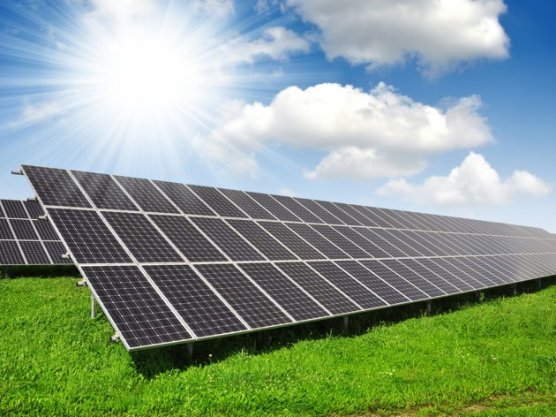

BIOFUEL
Biofuel is any fuel that is derived from biomass—that is, plant or algae material or animal waste. Since such feedstock material can be replenished readily, biofuel is considered to be a source of renewable energy, unlike fossil fuels such as petroleum, coal, and natural gas. Biofuel is commonly advocated as a cost-effective and environmentally benign alternative to petroleum and other fossil fuels, particularly within the context of rising petroleum prices and increased concern over the contributions made by fossil fuels to global warming.

Types of biofuels
Some long-exploited biofuels, such as wood, can be used directly as a raw material that is burned to produce heat. The heat, in turn, can be used to run generators in a power plant to produce electricity. A number of existing power facilities burn grass, wood, or other kinds of biomass.
Liquid biofuels are of particular interest because of the vast infrastructure already in place to use them, especially for transportation. The liquid biofuel in greatest production is ethanol (ethyl alcohol), which is made by fermenting starch or sugar. Brazil and the United States are among the leading producers of ethanol. In the United States ethanol biofuel is made primarily from corn (maize) grain, and it is typically blended with gasoline to produce “gasohol,” a fuel that is 10 percent ethanol. In Brazil, ethanol biofuel is made primarily from sugarcane.. Unlike the “first-generation” ethanol biofuel produced from food crops, “second-generation” cellulosic ethanol is derived from low-value biomass that possesses a high cellulose content, including wood chips, crop residues, and municipal waste.
The second most common liquid biofuel is biodiesel, which is made primarily from oily plants (such as the soybean or oil palm) and to a lesser extent from other oily sources (such as waste cooking fat from restaurant deep-frying). The use of algae and cyanobacteria as a source of “third-generation” biodiesel holds promise but has been difficult to develop economically. Some algal species contain up to 40 percent lipids by weight, which can be converted into biodiesel or synthetic petroleum. Some estimates state that algae and cyanobacteria could yield between 10 and 100 times more fuel per unit area than second-generation biofuels.
I Answer the following questions based on the information found in the texts provided above
HYDROPOWER
1.What is hydropower?
2.How do modern hydropower plants produce electricity?
3. What is the advantage of hydropower over other renewable sources of energy?
4. What are the bad sides of hydropower?
5. What kind of impact can damming have on the environment?
6. Is the construction of dams eco-friendly?
7. Explain the water cycle in your own words
SOLAR PANELS
- How can solar energy be used?
- What is depletion of resources?
- What is fossil fuel?
BIOFUEL
- What is biofuel?
- What is the difference between ’’first generation’’ and ’’second generation’’ ethanol biofuel?
- How is biodisel made?
- Which plant is most commonly used in production of biofules?

